Crowdsourcing & Open Innovation Project :

Green Guard A. I. Automata (G²AIA)

Supporting Open-Source Projects Enabling Autonomous Wildfire Suppression for Everyone

Forest Firefighters

André Augusto Ceballos Melo Conceptualization and Sponsor this project

Olivier Michel project development by cyberbotics / webots_ros
This simulation features a small forest wildfire and a few firefighter robots: a couple of drones and legged robots equipped with cameras. Users can run the wildfire simulation and program the behavior of the robots to fight the fire. They can also improve the models of the robot and even design new ones. 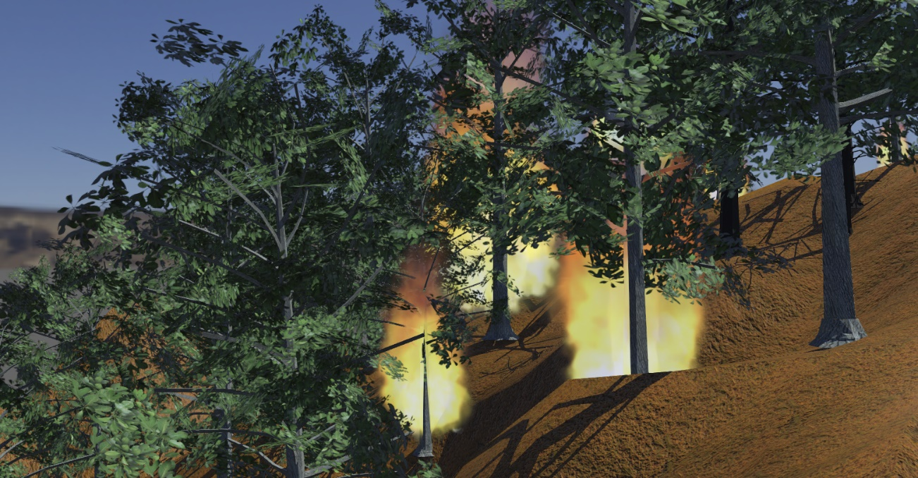
Connect at www.forestfirehub.com for more information about this project.
We finally terminated the autonomous drone programming using computer
vision to track down fires.
There are now two drones patrolling the forest, looking for smoke to
detect forest fires.
Once a fire is detected, one of the drone moves above the fire and
drops water on it to extinguish it.

You can see the result here:
https://github.com/cyberbotics/webots-projects/tree/master/projects/forest_firefighters

We finally terminated the autonomous drone programming using computer
vision to track down fires.
There are now two drones patrolling the forest, looking for smoke to
detect forest fires.
Once a fire is detected, one of the drone moves above the fire and
drops water on it to extinguish it.
You can see the result here:
https://github.com/cyberbotics/webots-projects/tree/master/projects/forest_firefighters
Fire seasons are running longer, stronger, hotter.
There’s a vicious cycle connecting forest fires and climate change: warmer temperatures make fires more likely, and burning forests release greenhouse gas pollution that makes global warming worse.
The world is getting warmer, the weather is getting worse.
Wildfires Can Affect Climate Change (and Vice Versa), We’re not here to persuade you. You already get it.

This means that overall efforts to reduce greenhouse gas emissions and slow global warming will also help prevent forest fires. And on the other hand, working to reduce the number and severity of forest fires will also help slow climate change.

Because we’re at a crucial inflection point in the journey.
And you need to be a part of what’s ahead. In a process of looking at forest fire in a new and unorthodox way
We need to adapt our wildfire response strategies to a world of more frequent, more intense fires.
Collaborate makes it easy for teams to save, share and sync projects. Collaborating like free Open Source Developers. Getting better and better at coordinating wildfire response.
Technology has the potential to change that, facilitating collaboration through new channels and tools for conducting cross-disciplinary (Internet of things (IoT),Swarm intelligence (SI), Automato Quadruped Robotics and UAVs (Unmanned aerial vehicles) in a computer-simulated environment, predicting trends and building strategies to turn data into actionable insights.
The first step?
Green Guard A. I. Automata (G²AIA)
An acronym for inception of the project and inspiration that stands for that the living and nonliving components of earth function as a single system in such a way that the living component regulates and maintains conditions so as to be suitable for life.

But the first questions to ask are radically simple ones: where are we making a positive impact? Could we have an exponentially bigger impact if we shared what we’re doing? What’s stopping us?
The objectives of the project are:
Swarm Intelligence Models in Simulated Environment For Autonomous Drone and Quadruped Robot Wildfire Suppression
Data-driven forest fire analysis (information about real time or historical data conditions) from a burning area, transform it into a simulation environment and obtain the best fire-fighting strategy. Reality-based generation of virtual environments for digital earth (mixture of real and virtual imagery), using satellite/aerial images and maps, virtual, augmented, and mixed reality combined.

To demonstrate the functionality and to verify that the concept can be achieved in development.
Developers will test their fire fighting methods with this simulation.
It’s about using – and improving on.
It’s a long-term approach to innovation and impact to demonstrate the functionality and to verify that the concept can be achieved in development.
A valuable exercise that allows developers to visualize how the product will function.
It is a working interactive model of the product that gives an idea of the design, navigation and layout.
Working on advances that helped revive interest in the field using an economical and easily reproducible setup as open source tools conforming to commercially available tech, specification, standards and current regulatory guidance
The source code to be used, modified and distributed commercially or non-commercially by anyone under the terms of GNU General Public License. The project is inspired by the revolutionary aspects of Linux that are social, not technical.
From the beginning, with the aim of being casually modified by volunteers coordinating only through the Internet.
The quality maintained by the simple strategy of obtaining feedback and insights from users, creating a kind of gradual and participatory evolution.
Freely redistributable, anyone can create a distribution.

For insights visit forestfirehub.com, there you can support us with your opinion or mini review.

If you’ve ever seen Smokey the Bear, you know that “Only YOU can prevent wildfires.” Over the past several years, you’ve probably watched news reports about the great damage that wildfires can cause. In addition to destroying forests, wildfires can burn homes and even take lives.
Science must evolves to be relevant to society

Humans have the option to use the results of scientific endeavour (Green Technologies & Solutions) or dispute and ignore them (like some people
on climate change)

Demo Videos
This video shows a wildfire propagating into one tree until the tree is completely burnt:
forest_firefighters.mp4
This video shows a Mavic Pro 2 that fights against a wildfire (speed x2):
forest-firefighters.mp4
This video shows two autonomous drones patroling over the forest, detecting and dropping water on wildfires:
forest-firefighters-autonome-mav.mp4

Creating Your Own Firefighter Robots
In order to contribute to this simulation by developing your own robot models and program their behavior you will have to follow these steps:
- download and install Webots on your computer.
- install python 3.8 on your computer if not already installed.
- follow the Webots Tutorials to get familiar with the software.
- clone this repository on your computer: git clone https://github.com/cyberbotics/webots-projects.git or download it from here and unzip it.
- run the simulation by opening the forest_firefighter.wbt world file in Webots.
- edit the robot controllers to change their behavior.
- create new robot models (or improve existing ones) and use them in the simulation.
For steps 6 and 7, please refer to the Webots User Guide and Reference Manual to get started with robot programming and robot modeling.

Technical Details

Forest Generation
An efficient and customizable forest can be generated using the proto protos/UnevenForest.proto. The size of the trees, the dimension and the density of the forest are all parameters of the proto.
Half burned forest using the forest generator: 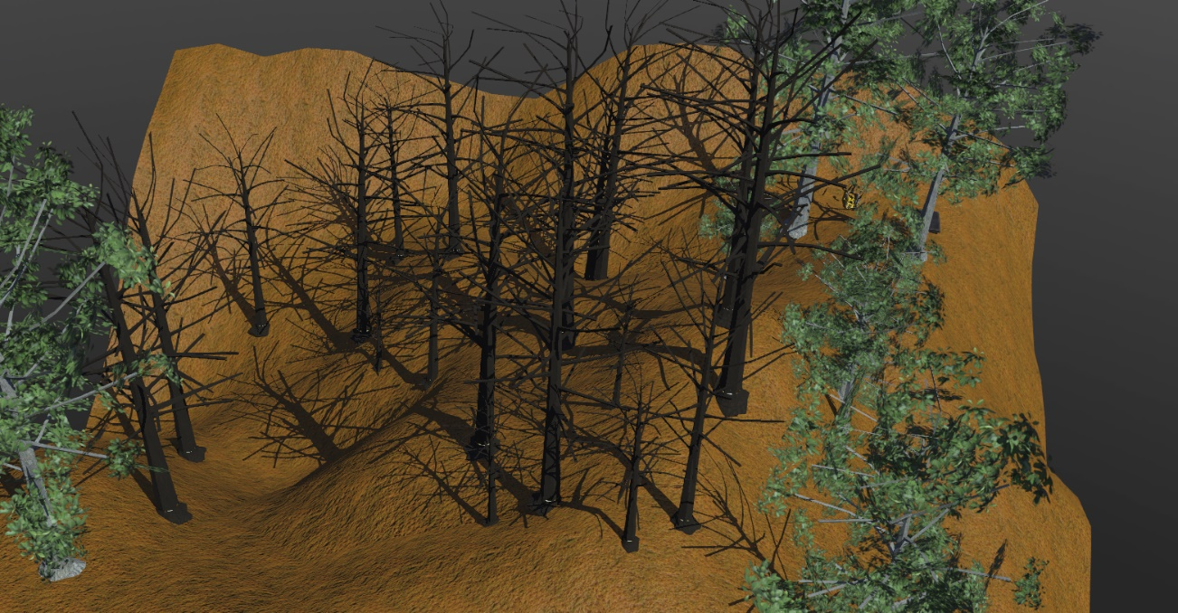

Fire
The fire starts randomly at one of the trees of the forest. It propagates randomly and according to the wind to other trees close to it. The fire of a tree stops naturally once the tree is completely burned. If some water dropped by a robot goes sufficiently close to a tree on fire and if the fire is not too big compared to the amount of water dropped, it extinguishes the fire instantly. The fire is run by a supervisor which can be found in controllers/fire/fire.py. Some fire parameters can be changed in this file:
- Fire.MAX_PROPAGATION: the maximum distance that the fire can propagate in meter.
- Fire.MAX_EXTINCTION: the maximum distance from which water can extinguish the fire.
- Fire.FIRE_DURATION: the duration of a fire to consume a tree completely.
- Wind.INTENSITY_EVOLVE: the speed at which the intensity of the wind evolve.
- Wind.ANGLE_EVOLVE: the speed at which the angle of the wind evolve.
- Wind.RANDOM_EVOLUTION: true if there the wind evolves randomly, false otherwise.
- Tree.ROBUSTNESS_VARIATION: the variation in the robustness of the trees (if a tree is more robust, it is less likely to burn).

Wind Window
The Wind window allows the user to modify the intensity and the direction of the wind during a simulation. The random evolution of the wind can activated/deactivated.
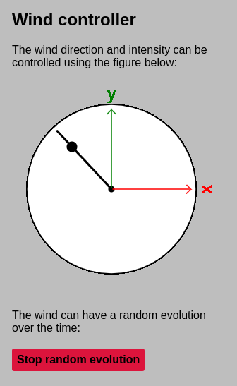

Mavic Pro 2 Demo Controller
The Mavic controller is a simple example controller. The keyboard can be used to move the robot and drop water on the forest fire.
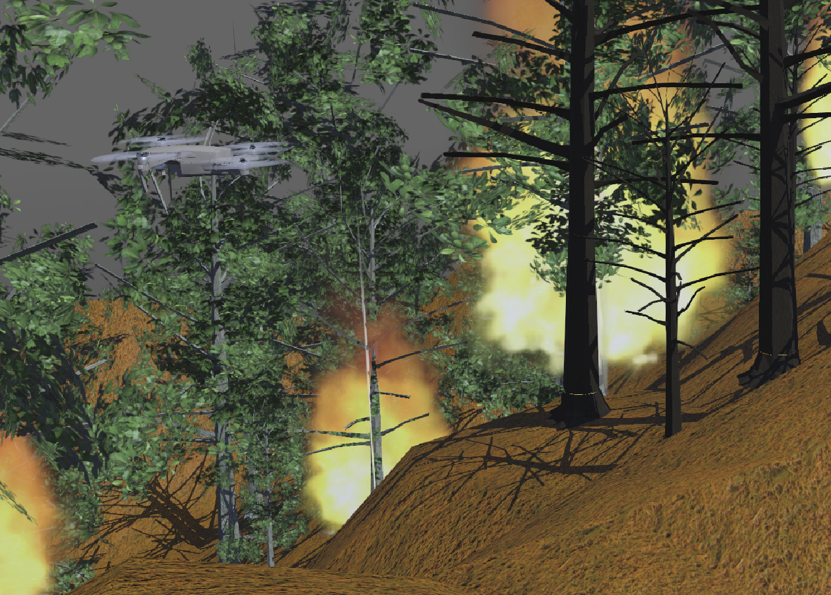

Spot Demo Controller
The Spot controller is a basic controller that just moves the legs of the robot. The keyboard can also be used to throw water on the forest fire.

Autonomous Mavic Controller
The autonomous Mavic drone moves between chosen coordinates above a forest in order to patrol and detect a fire. The altitude and world coordinates can be chosen through the controller args. Each time a fire is detected, the drone goes above the fire and drop a quantity of water to stop the fire. The project is using OpenCV to detect the smoke color range, and a naive approach to move above the fire (moves until the fire is in the center of the image). An alternative approach could be to use monoplotting to compute the world coordinates from the image coordinates of the fire (for example based on this method).
It is also possible to add multiple drones to increase chances of detecting a fire. Please note that the fire is starting only when the drone has reached an altitude of 40m.
To use the project, please install OpenCV pip install opencv-python.
Some features of the project in development process to be launched as a research and development plataform for autonomous wildfire supression technology:

- Enviroment built on Webots

- Build the terrain using realworld map data

- The software will simulate the dispersion of fire using an algorithm. Also calculate the wind effect.

- This simulation will have drones and quadruped robots. Developers (eg cooperative participants) will be able to use these tools.

- Image processing can be done with cameras on robots and drones.

- The software will simulate the progress of the fire

- The administrator will use an interface to control wind speed, wind direction and similar physical and environmental elements with simulation settings made in an interface.

-Computer models using data, math and computer instructions to predict events in the real world.

-Data-driven forest fire analysis (information about real time or historical data conditions) from a burning area, transform it into a simulation environment and obtain the best fire-fighting strategy.

-Reality-based generation of virtual environments for digital earth (mixture of real and virtual imagery), using satellite/aerial images and maps, virtual, augmented, and mixed reality combined.

-Simulating the forest fire plume dispersion, chemistry, and aerosol formation

- AI to control drones and quadruped robo: Deep Reinforcement Learning

Essentially rule-based structures for making decisions. In general, conforming to commercially available tech, specification, standards and current regulatory guidance.

Why Are These Insights Valuable?
Inspire, motivate and be curious about the data and the possibilities it has for firefighting
Spot the potential opportunities.

These insights have many uses, including:
Data Analysis:
Customizing data as insightful visualisations
Directing future data collection
Extrapolating current trends
Designing for scale:
Designing with the next generation of drones and quadruped robots in mind.
Building for error-prone environments in the real world.
Informing feature engineering
Integration:
Informing human decision-making
New efforts without disrupting current and future fire fighting forces
Smart Action Planning:
Intelligently route the right alerts to swarms of robots operations
Customizable alerts are triggered or cleared at specific severity levels to help strategic planning.
Cross Border Cooperation in microgrids

Always Alert:
Proactive issue detection and prevention models.
Time analysis and alert propagation brings down fire alerts time from hours to seconds.

Ethical Concerns:
Certainly, drone and robotic quadruped will need to play by the rules and follow regulatory guidelines, especially in emergency situations.
Evaluating, as Open Source recommends, a variety of issues including ethical concerns by contributors representing a wide range of viewpoints.
Wildfires are destructive forces, but they can occur naturally. Because of this, certain plants and animals have evolved to depend on periodic wildfires for ecological balance.
It might seem counterintuitive that a fire, which burns plant life and endangers animals within an ecosystem, could promote ecological health. But fire is a natural phenomenon, and nature has evolved with its presence.
Human-induced climate change promotes the conditions on which wildfires depend, increasing their likelihood — according to a review of research on global climate change and wildfire risk.
In the end, it is true that the burden of preventing uncontrolled wildfires lies with humanity
Not meant to be competitors with the firefighters, we want to be complementary

Because drones can fly day or night and gain rapid access to previously inaccessible urban or rural fires they can help to save both the lives of the public and first responders. Using intelligent robots to scout the area and drop water or Fire Retardant can allow humans to stand further back from the danger zone, only looking at the drones’ data to make decisions from the safety of a command and control centre.
Firefighting automation is inevitable. It’s just a matter of time when tech will have the potential to alleviate challenges people face every day.

Cross Border Cooperation is a key element to be considered
The age of fire is upon us, climate change is subverting the system. The fires of this new era cannot always be tamed. Neither aircraft nor ground crews can do much for the blazes that spread quickly with powerful winds. That has forced firefighting “to be a global effort, not a state or national effort. Time to rethink the system of neighbours resource sharing.

Finding and identifying opportunitys, developing the projects for installation and operating the microgrids.

Precision Firefighting
Introduce the concept of Precision Firefighting for Early Site Specific Fire Management. As “a management strategy that uses information technology to bring data from multiple sources to bear on decisions associated with firefighting. Encompassing techniques and methods for firefighting management by taking into account their local and site-specific heterogeneity and variability

Biomimetics can given rise to new technologies inspired by biological solutions
Research Article | Open Access
Volume 2012 |Article ID 780713 | https://doi.org/10.1155/2012/780713
Leafcutter Ant Nests Inhibit Low-Intensity Fire Spread in the Understory of Transitional Forests at the Amazon's Forest-Savanna Boundary

New autonomous driving technologies inspiring new solutions:

Please make the following modifications in the open software / hardware
The robot can be used as a unit or in swarming group formation, with machine learning for optimization
After deploying or using the firestinguisher or when the battery is low it can automatically come to refuel station or gahering point.
Localization of focus of forest fire is achieved by 3D maps in combination with sensors and real time data localization (from drone or satellite).Modifications in the open software

Freely redistributable, anyone can create a distribution.
This highly creative activity can be highly technical, simply clever, or both.
In general, conforming to commercially available tech, specification, standards and current regulatory guidance.
Crowdsourcing has become a mainstream alternative for innovation initiatives to create new ideas, best practices are emerging.

If possible ad this features: Simulating the forest fire;Deep Reinforcement Learning to control
Swarm Intelligence Models in Simulated Environment For Autonomous Robot Wildfire Suppression
If you don't get everything, do something simpler just to present a proof of concept
To demonstrate the functionality and to verify that the concept can be achieved in development.
A exercise that allows developers to visualize how the product will function.
In the end provide the working software as available open source code in GitHub
To introduce the concept of Precision Firefighting for Early Site Specific Fire Management.

"An object at rest will remain at rest unless acted on by an unbalanced force."
Newton’s first law explains why it takes extra force to get moving
This same principle serves to explain the difficulty of starting a project
This is a chance to do good, and shine. Seize it!
We are confident that you will be there to support us.
For more information and insights:
See Our Sister Sites | Digital Suggestion Box
sense-hub.com
safeairship.com
forestfirehub.com
2gaia.com
Support us with your opinion or mini review for one of this issue. I hope you can participate, and shared yours interesting ideas.
So absorb this ideas, take them to your team, share, discuss, argue and conspire.
But most of all, act. Tell us what do you like (and what not!) To help us understand you better, and to give us your feedback, thoughts and suggestions on how we can continue to improve and develop in the future.

